Version 6 August 2023

AUDLEY MEDICAL PRACTICE

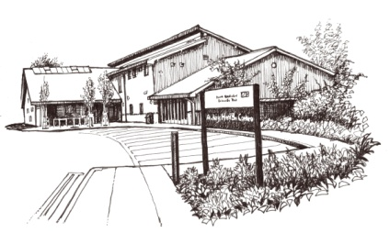
Practice Leaflet for Patients

CHURCH STREET
AUDLEY
STOKE ON TRENT
ST7 8EW
TEL: 01782 276999
EMAIL: audley.admin@nhs.net

www.audleyhealthcentre.co.uk

Richard John Page MBChB. FRCS.Ed. MRCGP MFFLM DFMB (qualified Birmingham 1981)

Kenneth Henry Hall BSc MBChB MRCGP DRCOG DFFP Cert Med Ed (qualified Manchester 1986)

Emma Jane Sutton BMedSci. BM.BS. M.R.C.G.P D.F.F.P. D.R.C.O.G. D.P.M. (qualified Nottingham 1991 )

Amanda Jane Sweet M.B. Ch.B D.R.C.O.G. D.F.F.P (qualified Wales 1998)

Joseph Charles Hassell MBChb BSc (qualified Leeds 2013)

Elizabeth Marie Wharton MBChB MRCGP FRCS (Plast) MSc DTMH (qualified Sheffield 1999)

Page 13

Practice Area

We accept patients living within the boundaries marked below. A larger scale map is available within the surgery. We have a policy of preferring to take families as a whole, rather than individuals. For further details, contact Rebecca Winwood, Practice Manager.

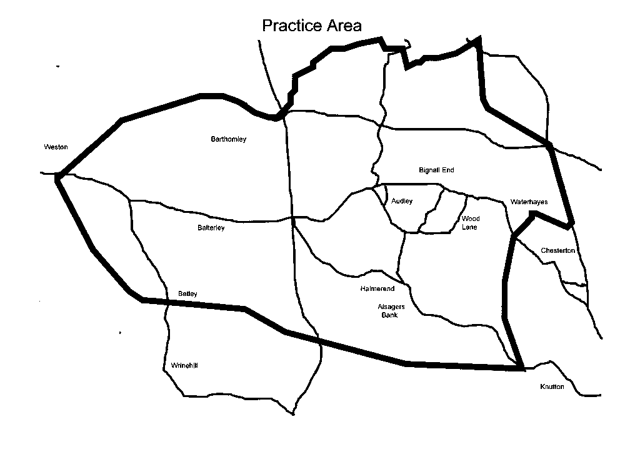

Existing patients who move outside our area will be asked to re-register with another practice, to ensure that we can fulfil our commitments to those within it.

Page 12

The Doctors
Richard John Page MBChB. FRCS.Ed. MRCGP MFFLM DFMB (qualified Birmingham 1981)
Kenneth Henry Hall BSc MBChB MRCGP DRCOG DFFP Cert Med Ed (qualified Manchester 1986)
Emma Jane Sutton BMedSci. BM.BS. M.R.C.G.P D.F.F.P. D.R.C.O.G. D.P.M. (qualified Nottingham 1991 )
Amanda Jane Sweet M.B. Ch.B D.R.C.O.G. D.F.F.P (qualified Wales 1998)
Joseph Charles Hassell MBChb BSc (qualified Leeds 2013)
Elizabeth Marie Wharton MBChB MRCGP FRCS (Plast) MSc DTMH (qualified Sheffield 1999)

The doctors provide maternity, contraceptive, child health surveillance and minor surgery services.

Teaching Practice
The Practice is an established teaching Practice and trains both undergraduate and postgraduate doctors. Usually we have two on
a GP Specialist Training scheme. Both are attached to the North Staffordshire GP Vocational Training Scheme. We also have a Foundation Level 2 doctor who is a junior Doctor attached to the University Hospital of North Staffordshire, gaining valuable experience in General Practice as part of basic training. All training Doctors are supervised. Our undergraduate medical students are from Keele University. We have 3rd year and final year students. You do not have to see a student if you don’t want to, but it would be helpful if you could let the receptionist know at the time the student appointment is offered to you.

Page 1

Surgery Opening Times
Monday | 8:00 – 18:30
Tuesday | 8:00 – 18:30
Wednesday | 8:00 – 18:30
Thursday | 8:00 – 18:30
Friday | 8:00 – 18:30
Weekends and Bank Holidays | CLOSED
Please refer to website for any changes to opening times

The Nurses
Gail Jervis Practice Matron
Jill Griffin BSc. (Hons) Dip.N.(Prac.Nursing). SRN. RSCN. FP Cert
Julie Shaw, Dip.N (Prac Nursing). RGN.
Rudy McKinney, DipHe (Adult nursing) RGN, Cert diabetes care
Elizabeth Handley, Dip.N (Prac Nursing). RGN.
Ann Woolley, Health Care Assistant
Emma Gibson, Health Care Assistant
The nurses undertake a full range of nursing duties and medical check-ups.

The Practice Manager
Rebecca Winwood.
Rebecca is the point of contact for anyone with a problem concerning the working of the practice, rather than a medical problem. She is also the point of contact for any complaints that may arise

Reception Staff
Our Care Navigators are here to help you and are trained to do a difficult job. We ask therefore that you treat them with respect and courtesy. They may need to ask you for information when you telephone or visit the surgery. This is to ensure that we can assist you appropriately and as quickly as possible. The reception staff are bound by the same rules of confidentiality as the doctors and nurses.
Page 2
Hospital Related Complaints – PALS
PALS (Patient Advice and Liaison Service) offers confidential advice, support and information on health-related matters. They provide a point of contact for patients, their families and their carers.

PALS provides help in many ways. For example, it can:
- help you with health-related questions
- help resolve concerns or problems when you’re using the NHS
- tell you how to get more involved in your own healthcare

PALS can give you information about:
- the NHS
- the NHS complaints procedure, including how to get independent help if you want to make a complaint
- support groups outside the NHS
- PALS also helps to improve the NHS by listening to your concerns and suggestions.

Royal Stoke PALS: 01782 676450
Leighton Hospital PALS: 01270 612410

Patient Panel
The Audley Patient Panel are a group of patients working with the practice to:
- Contribute to the continuous improvement of services;
- Foster improved communication between the practice and its patients;
- Help patients take more responsibility for their health; and
- Provide practical support and help to implement change
For more information visit the Audley Patient Panel Website: www.facebook.com/AudleyPPG Page 11

North Staffordshire and Stoke on Trent Intergrated Care Board (ICB)
North Staffordshire and Stoke on Trent ICB, who we contract to, can be contacted on
Freephone: 0808 196 8861– There is also a 24 hour answer phone service.
Email: PatientServices@staffsstoke.icb.nhs.uk
Website: www.staffsstoke.icb.nhs.uk

Violent or abusive Patients
The Practice operates a Zero Tolerance Policy. Patients who are behave in a violent or abusive way will be removed from the list with immediate effect.

Complaints
We try hard to give the best possible care and welcome suggestions or comments to help us improve our service. If you have a complaint or any concern about the service that you have received, please let us know. We operate a complaints procedure as part of the NHS system for dealing with complaints. Our complaints procedure meets national criteria. Complaints should be addressed to Mrs Rebecca Winwood, Practice Manager. She will contact you and discuss your complaint. We shall acknowledge your complaint within two working days and aim to have looked into your complaint within ten working days of the date you raised it with us. We shall then be in a position to offer you an explanation, or a meeting with the people involved. When we look into your complaint, we shall aim to: find out what happened and what went wrong. Make it possible for you to discuss the problem with those concerned, if you would like this. Make sure you receive an apology where this is appropriate. Identify what we can do to make sure the problem does not happen again. All complaints are documented and you will be advised in writing of the outcome of the complaint. Further information is available in our practice complaints leaflet, which is available on request.
Page 10

Services
Many services are available at our clinics, including:
- Asthma management
- Diabetes management
- Hypertension
- Family Planning
- Cardiac disease management
- Child Development & Immunisation
- Minor surgery
- Travel Health advice & Immunisation
- Well-person screening
- Physiotherapy
- Adolescent Mental Health Practitioner
- Dietician
- ECG’s
- Anticoagulation Clinics
- Social Prescribing
- Health & Wellbeing Practitioner

This is not an exhaustive list, but designed to illustrate the range of services that we can offer.

Page 3

Appointments

The Practice operates an Advanced Access appointment system and aims to offer same day appointments to those who want them. Our appointments are split 50:50 with 50% being available for ‘advanced booking’ with the remaining 50% being ‘book on the day’. If you require a routine appointment for either a new or ongoing problem you will be able to telephone on the day you require your appointment. A number of appointments are available to book in advance. These will be either follow-up appointments, where a GP has asked to see you, or ‘future’ appointments for patients who are unable to attend ‘on the day’. These will be available up to 2 weeks in advance.
Wherever possible you will be offered an appointment with the doctor of your choice; however once a doctors surgery is full you will be offered an appointment with an alternative GP or asked to call back on a different day. Please note that all the GP’s are not in surgery for every session.
An appointment is for one person only. We are a group practice and you may see any of the doctors, not just the one that you are
registered with.

Care Navigation (Reception) Explained
Our care navigators are here to help you get to the right service at the right time. Please don’t be offended if they ask what the problem is when you call to make an appointment. The receptionist might suggest other professionals that could help you better such as: Opticians, Pharmacist, Nurse, Dentist or Support Group. Depending on the nature of your call, they may also advise you call for emergency services rather than wait for a GP appointment or they may connect you with the on call Doctor for further advice if needed. By working in cooperation with our care navigators you will be directed to the most appropriate professional in the shortest time.
Page 4

Specialist and Hospital Care
If a Doctor or another member of our health care team believes you need hospital treatment or specialist care elsewhere, they will ask you where and when you would like to go. They can then book your appointment electronically. If you would prefer to have some time to think before deciding where and when to have treatment, you will be offered the option of calling the practice later and we will be able to book your appointment then.

Patient Confidentiality/ Information

Your doctors, their staff and everyone else working for the NHS have a legal duty to maintain the highest level of confidentiality about patient information. We may need to share this information about you with them, so that we can all work together for your benefit. Anyone who received information about you from us is also under a legal duty of confidence. Unless there are exceptional circumstances e.g. when the health and safety of others is at risk, we will not disclose information to others without your permission. We will only give your relatives, friends and carers information about you with your consent. This will need to be in writing. We may also ask for identity to ascertain the identity of the individual. You should never be asked for personal medical information by anyone not involved in your care.
How you can help us
- Be on time for your appointment
- Tell us if you need to cancel
- Call for a home visit or urgent appointment before 10.30am
- Order your repeat prescription in plenty of time
- Ring for test results after 2pm

Page 9

Patients with particular needs
The surgery has access and facilities for disabled patients. We also have disabled parking spaces which are reserved for patients displaying a disabled sticker. For patients with hearing problems we have a loop induction kit; please inform the receptionist if you need this service.
We want to get better at communicating with our patients.
We want to make sure you can read and understand the information we send you.
If you find it hard to read our letters or if you need someone to support you at appointments, please let us know.

- We want to know if you need information in braille, large print or easy read.
- We want to know if you need a British Sign Language interpreter or advocate.
- We want to know if we can support you to lip-read or use a hearing aid or communication tool.
Please tell the receptionist if you need information in a different format or communication support.

How to Register as a Patient
The Practice accepts patients who live within the boundaries as described in the Practice Booklet.
To register new patients need to fill in Form GMS1 ‘Family Doctor Services Registration’ or you can register online on our website. New patients will be offered and encouraged to attend a new patient medical with the practice nurse within three months of registration.
You will be registered on the list of one of the Partners. However, as this is a group practice, you will be able to see any doctors in the practice

Page 8

Repeat Prescriptions
Repeat prescriptions will be available within 2 working days from receipt of the request. Repeat prescriptions are usually given for 28 days with the exception of specific drugs. If an item on your prescription is marked for ‘For Review see GP’ you may need to see a GP. A Doctor will review the prescription and inform you on your repeat slip what type of appointment you need. Please inform the receptionist if this applies to you in order to save yourself an unnecessary visit to the surgery. You can request a repeat prescription by:
- Calling our dedicated prescription line on 01782 276980 which is open Monday to Friday between 11am and 12pm.
- Completing the right-hand section of your previous prescription form and posting in the prescription box
- Order a repeat prescription through the NHS or Patient Access App

Appointment Availability
During busy periods you may have to wait a few days to see the doctor of your choice. Our appointments are for 10 minutes but appointments with our training doctors and medical students may take 20-30 minutes. If you have complex or multiple problems, the doctor may ask you to re-book a double appointment. This will prevent the patients after you being inconvenienced due to over-running appointment times.

If you make an appointment you will be expected to attend for this or to cancel it with reasonable notice.

Telephone access will not be available after 6.30pm and telephone calls to the surgery will be automatically diverted to our out of hour’s service – NHS 111.

Page 5
Online Access
Patients can book GP appointments, order repeat prescriptions and view medical history using the Patient Access or NHS App. To register please ask Reception for an online access form, 2 forms of ID may be required.

Triage
The Nurses operate a telephone triage service Monday to Friday between 08:30 a.m. and 10:30 am. This is to make sure that you get the best service that is appropriate to your needs. Our Triage Nurse, who has undergone extensive training to develop the necessary Triage skills, will ring you back the same day to discuss your problem further. You will then be offered either advice on self-management, a same day appointment with the doctor on call, an appointment with the Nurse practitioner, an appointment within 24 or 48 hours or a routine appointment, depending on what is the most appropriate treatment for your illness.

If you are on the Triage list for a call, please ensure that you are available to take the call as further call backs outside of the set Triage hours cannot always be accommodated and that we have an up to date contact number for you.

Home Visits
If you are unable to get to the surgery and request a home visit, please do so before 10:30 a.m. in order to assess the urgency and plan accordingly. Either the Triage nurse or one of the doctors may call you back for further details, to give advice, to arrange to see you at the surgery or to arrange the home visit by our paramedic who will liaise with the doctor on call. We therefore ask that you request a home visit only when absolutely necessary. We follow national guidelines on visiting and you should note that transport difficulties do not alone justify a home visit.
Page 6
When the Surgery is Closed
NHS 111 is a new service to make it easier for you to access local NHS healthcare services in England. You can call 111 when you need medical help fast but it’s not a 999 emergency. NHS 111 is a fast and easy way to get the right help, whatever the time. NHS 111 is available 24 hours a day, 365 days a year. Calls are free from landlines and mobile phones.
If you require emergency assistance you should always call 999

Haywood Walk-in Centre, High Lane, Burslem, S-O-T,

Tel: 673500

The Haywood Walk-in Centre provided treatment for minor injuries and ailments together with general health information and advice seven days a week. You don’t need an appointment and you will be seen by an experienced NHS nurse.

Accident & Emergency/999
Whatever the day or time, if you or someone else experiences severe chest pain, severe loss of blood or suspected broken bones, go to your nearest Accident & Emergency Department or call 999. Accident and Emergency Department are open 24 hours a day, 365 days a year and can assess serious injuries and provide emergency treatment.

Page 7

