Practice Information Leaflet

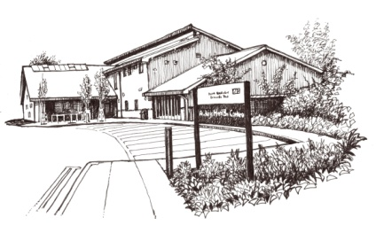

Audley Medical Practice is a partnership providing NHS Services under an NHS England General Medical Services Contract.

CHURCH STREET
STOKE ON TRENT
ST7 8EW

Telephone No. 01782 276999

Email address:
audleyadmin@staffs.nhs.uk

Website:
www.audleyhealthcentre.co.uk

Opening hours
Mon–Friday | 8:00 am | 6:30 pm
Saturday | Closed | Closed
Sunday | Closed | Closed

Improved access/Extended hours
As part of Newcastle North Primary Care Network, we deliver extended hours on a Saturday. We share these hours on a rota across our five practices.

As part of the North Staffordshire GP Federation, we offer pre-bookable evening and weekend appointments at local hubs.

Services we provide
In addition to the routine services that are provided, this practice also offers the following:

- Family planning – We offer a full range of family planning services
- Immunisations – The clinical team administers vaccines for both adult and child immunisations.
- Minor surgery – Your GP will advise on minor operations.
- Phlebotomy – We offer a limited number of blood test appointments at the practice.
- Cervical smear testing – For women aged 25 – 64 and these tests are undertaken by the nursing team.
- Chronic disease management – We hold a range of clinics to help our patients to manage their long-term medical problems including asthma, diabetes, hypertension, kidney disease and heart disease.
- Dermoscopy - At Audley Health Centre, we offer appointments with Dr Page, Dr Sweet and Dr Wharton to assess skin concerns such as moles and lesions.
- Health checks – A health check will be offered to any new joiners to the practice. Furthermore, NHS health checks are offered every 5 years after a patient’s 40th birthday dependent on whether they have any chronic disease.
- Other clinics – The practice also offers antenatal, post-natal, smoking cessation, counselling for drug and alcohol addiction

Details of all clinics are available from reception and are also listed on the practice website.

From time to time, other services may be available such as raising awareness of a particular disease or condition. We will advertise this information.

Teaching practice
The practice is a teaching practice and regular supports the training of future doctors. Trainee GPs, Foundation Year 2 doctors and Medical Students may, as part of their training, be required to sit in with their trainer GP during consultations with patients.

You will always be asked if you consent to this prior to your consultation. If you do not consent, the trainee will not sit in on your consultation.

How to register at the practice
The quickest way to register is to use the practice website. You must live within the practice area which is shown on the website. If you are unable to use the website, please contact the practice for information about how to register.

Access and support for disabilities
The practice offers step free access to the premises. Additionally, there is a hearing loop on the reception desk, large print leaflets are available, and we also have dementia friendly signs.

We welcome Assistance Dogs although animals are not permitted in any clinical areas.

Patients’ rights and responsibilities
When registering, you have a right to express a preference to be seen by a particular GP. This will be recorded on our clinical system and, where possible, you will be allocated appointments with that clinician. All patients will be assigned an accountable GP.

Further information about your rights and what we expect of our patients are detailed within the NHS Constitution.



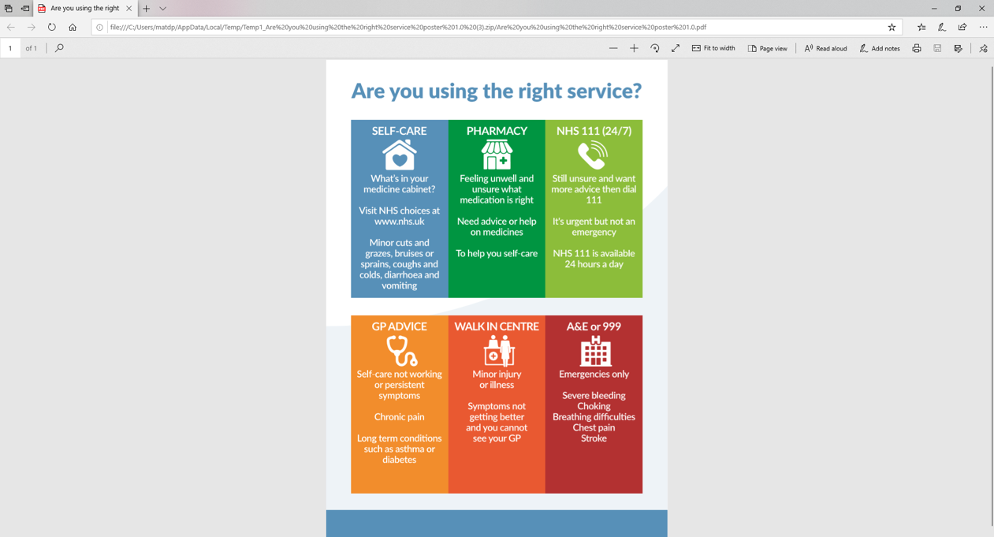

Preference for a named practitioner
The practice will attempt to ensure that any patient is seen by the same healthcare professional although please note that this may not always be an option. All patients
provided with a named GP.

Comments, suggestions and complaints
Our aim is to give the highest possible standard of service. We would like you to tell us what you think about the service we provide.

If you would like to offer a comment or suggestion or raise a complaint, this can be raised with any member of the team. Further information about this can also be found on the practice website or within the complaints leaflet.

Home visits
At Audley Health Centre, all GP appointments use a total triage system. Please contact us via the online form on our website or the NHS App. If you cannot access these, call the practice for help.
Home visits are for patients who are housebound or have significant health issues and are arranged at the GP’s discretion. To request a visit, please contact us before 10:00 am via the website or phone.
You may receive a home visit from the Primary Care Network paramedic, who works closely with the practice and will consult the doctor about your care.
When we are closed
When the practice is closed, if you urgently need medical help or advice and it is life threatening, dial 999. If it is not life-threatening, contact NHS 111 by calling 111 or via www.nhs.uk

NHS England Contact
The practice provides NHS services on behalf of NHS England

PO Box 16738, Redditch, B97 9PT.
Telephone: 0300 311 2233
Email: england.contactus@nhs.net

Prescriptions/repeat prescriptions
Your GP will initiate any prescription that they determine you require. Repeat prescriptions can be ordered in the following ways:

- In person – By ticking the required medications on your prescription and placing it in the dedicated box, located by the main doors
- By telephone – Please call the practice on 01782 276999
- Online – Download the NHS App
- Please allow 48 hours for processing and 5 working days for the pharmacy (excluding weekends and bank holidays) when ordering repeat prescriptions.

The practice team
This practice operates under a partnership agreement and provide services on behalf of the NHS.
Partners
Richard John Page MBChB. FRCS.Ed. MRCGP MFFLM DFMB (qualified Birmingham 1981)

Kenneth Henry Hall BSc MBChB MRCGP DRCOG DFFP Cert Med Ed (qualified Manchester 1986)

Amanda Jane Sweet M.B. Ch. B DRCO DFFP (qualified Wales 1998)

Joseph Charles Hassell MBChB BSc (qualified Leeds 2013)

Rudy McKinney MSc Masters

Salaried GPs
Elizabeth Marie Wharton MBChB MRCGP FRCS (Plast) MSc DTMH (qualified Sheffield 1999)

Melissa Morton MBChB BSc (Hons) MRCGP DFSRH (Qualified University of Manchester 2015)

Nurses
Gail Jervis, Practice Matron, BSC degree
Jill Griffin, BSc (Hons) Dip.N.(Prac.Nursing). SRN. RSCN. FP Cert
Rudy McKinney, DipHe (Adult nursing) RGN, Cert diabetes care, MSc Masters
Elizabeth Moy, DipHe Diploma Nursing BSc Sociology
Katie McKenzie, DipHe Diploma Nursing Fundamentals to practice nursing

Other healthcare staff
[Insert names, roles and professional qualifications]

Practice Manager
[Insert name] [optional to add PM details]

Other management
[insert names and roles]

Appointments and accessing practice services

At Audley Health Centre, we operate total triage for GP appointments. Use the online form on our website or use the NHS App to contact your GP about a health problem.
Should you be unable to access the website, contact the practice and a member of our administrative staff will be able to assist you.

The practice website contains all the relevant practice information that you are likely to require. It is the quickest way to access the services you may need.
Threats of violence or abuse of our staff
Our staff work hard to provide you with the best possible service. Please treat them with the courtesy and respect they deserve. We operate a zero-tolerance policy and may refuse to provide services to individuals or those accompanying individuals who are violent, threaten violence, commit or threaten to commit a criminal offence

Patient Participation Group
We have an active Patient Participation Group (PPG), ensuring that our patients are involved in decisions about the services provided by the practice.

Further information about our PPG is available online at www.audleyhealthcentre.co.uk.

Patient data
All clinical and administrative staff have an ethical as well as a legal duty to protect patient information from unauthorised disclosure and in accordance with the Data Protection Act 2018.

The patient privacy notice is available on the practice website.

